//Student Name -: Sandeep Sandeep

//Student Id -: 25461

//Student Email -: [25461@student.dorset-college.ie](mailto:25461@student.dorset-college.ie)

A PDF report should be describe what you have done and the challenges you encountered and include screenshots of your application

Start with first screen which is shows list of movies

Use Technologies:

1. Xml with viewbinding

2. Kotlin

I used for showing movie list:

1. activity (set Recycler view)
2. list item layout
3. adapter (showing data into views)
4. . modal class (set and get data)

**1. Activity xml 🡪**

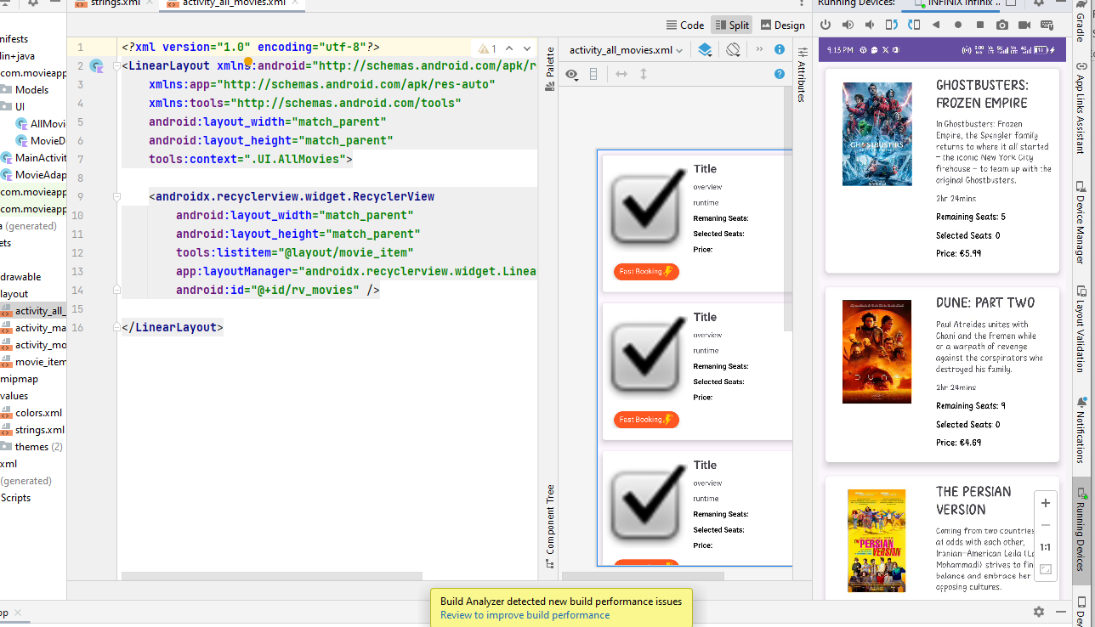

Here is used androidx recycler view for showing movie list

**AllMovieActivity.java file where is backend code for set recycler view:**

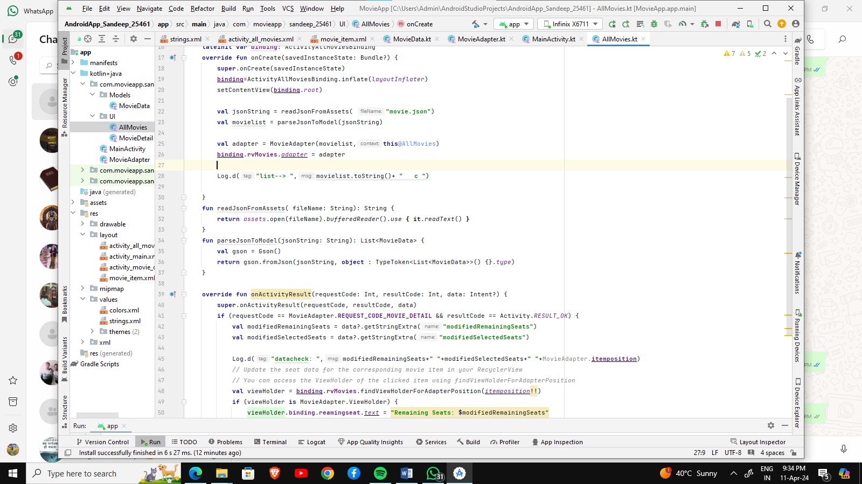

**2. Movie List Item layout🡪**

This is item layout for showing movie list 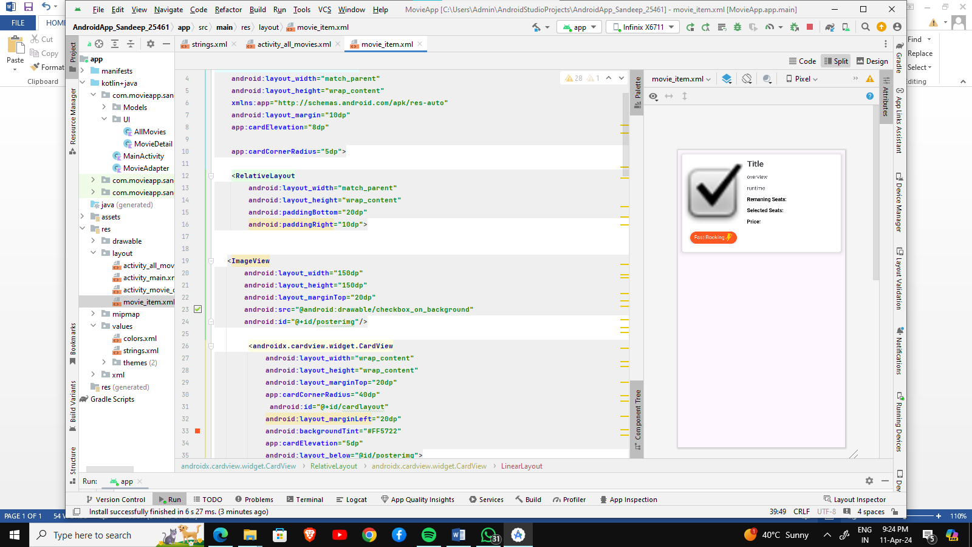

**3. Modal Class🡪**

Here all data which is set into item view   
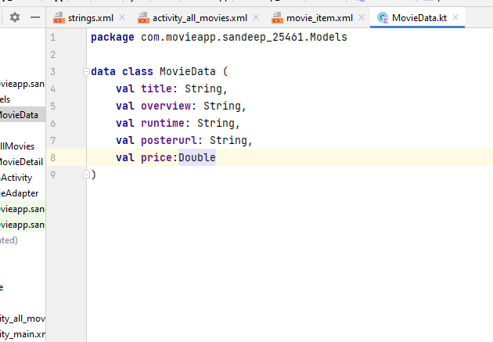

1. **Movie Adapter.java file where data is set into views like price, title and description etc.** 🡪

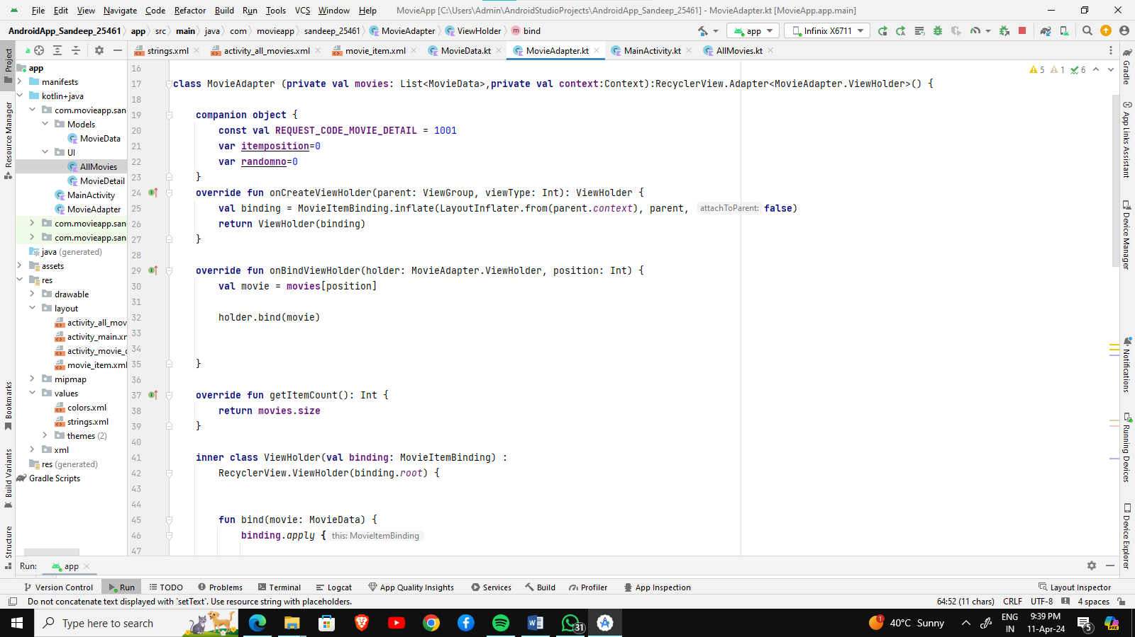

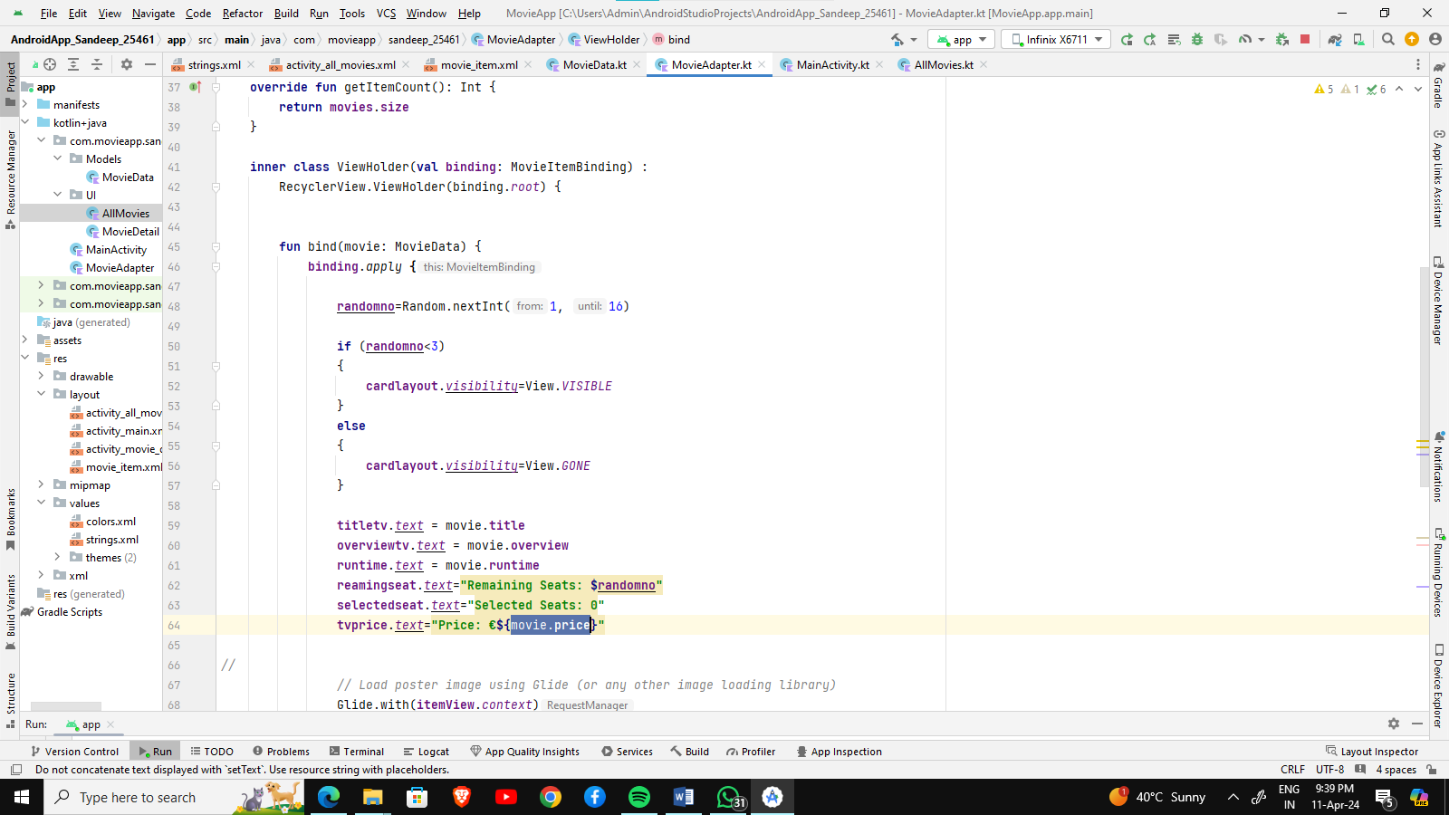

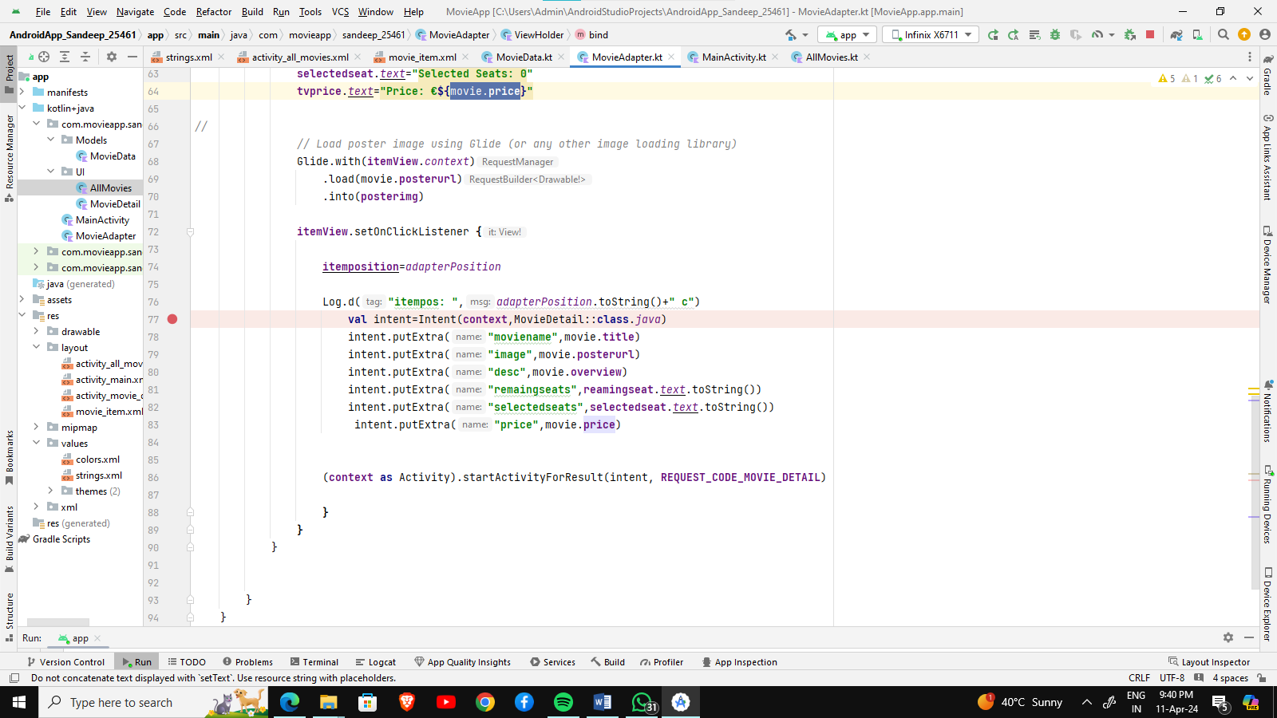

**Output of all process:**

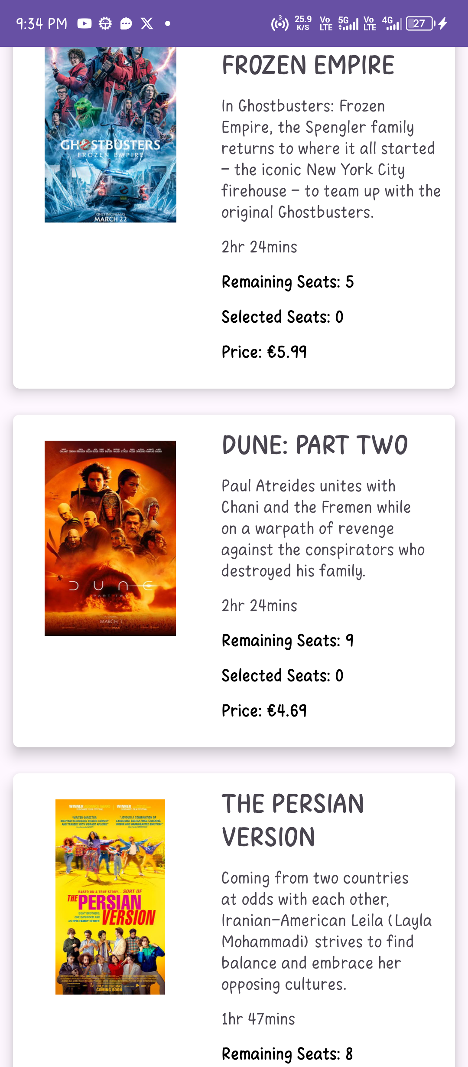

**2 . When user click on any movie item from list then it goes to Movie Details Activity**

In this page I get all data about movie from all movie list page because when I click any item I pass all data about movie into movie details activity using intent passing

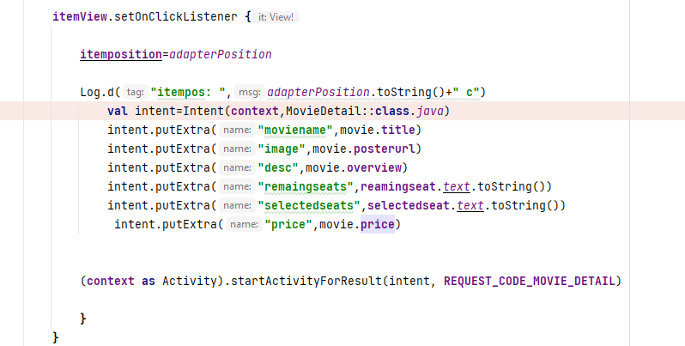

Here is movie details. Xml file:

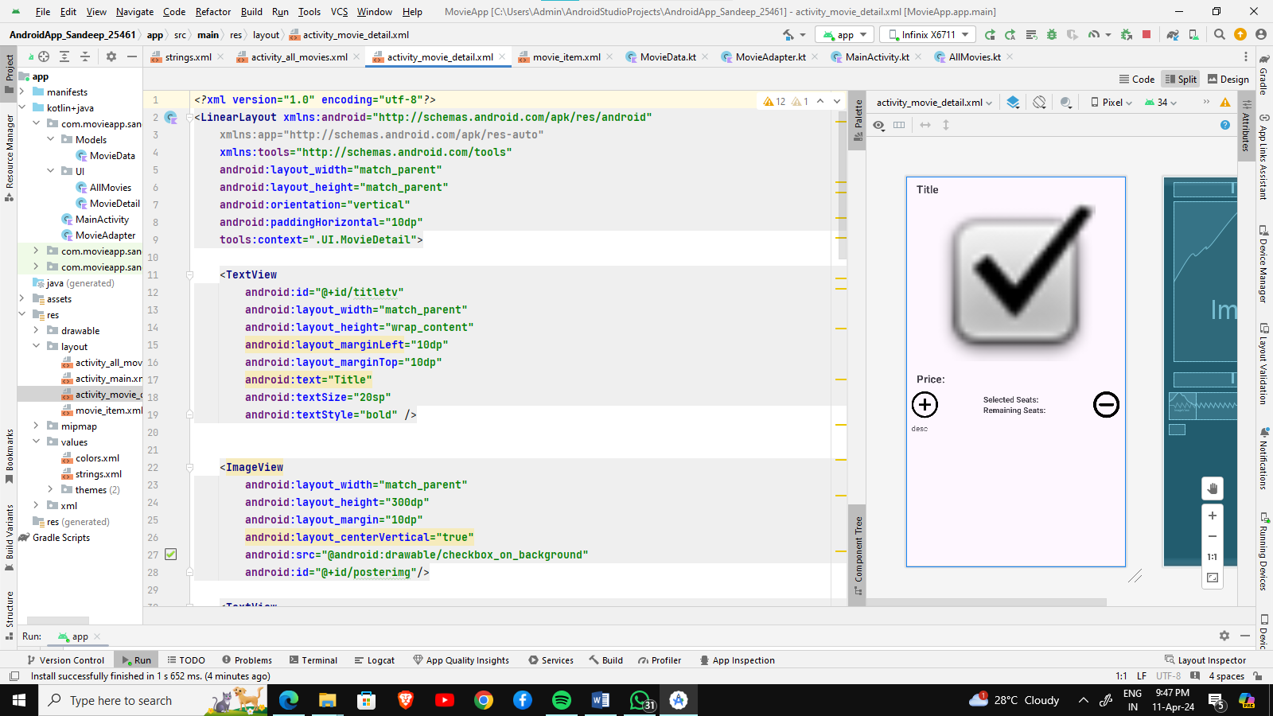

Output:  
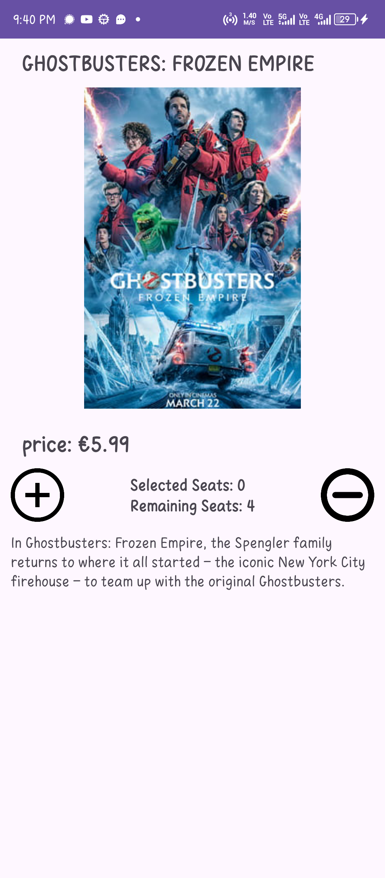

1. when user click plus button then selected seats is increased with price and remaining seats is decreased till remaining seats 0 after 0 remaining seats plus button will not work it can’t be negative
2. when user click minus button then price is decreased , selected seats decrease and remaining seats is increased

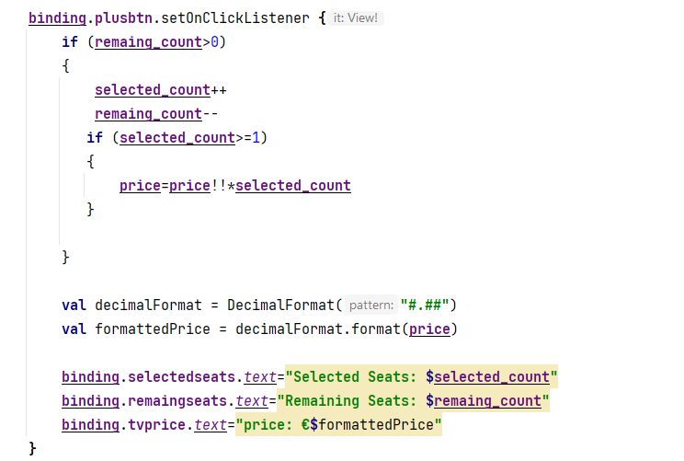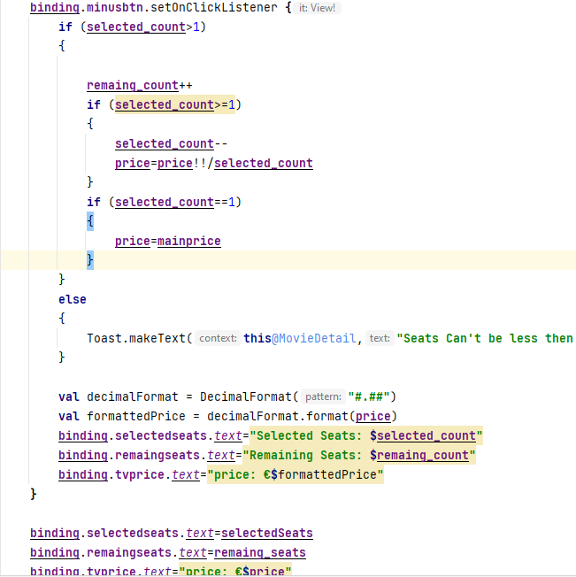

This is complete application of movie android app .